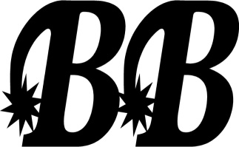
WAIVER OF LIABILITY/DOUBLE B RANCH
PLYMOUTH, MA 02360
Horseback riding is a dangerous activity and involves risks that may cause serious injury and in some cases death, because of the unpredictable nature of horses, regardless of their training and past performance. The Double B Ranch and Bob Burrelli Natural Horsemanship (hereafter referred to as the Ranch) requires all equine activity participants to wear a safety approved helmet each and every time they ride. The wearing of a helmet during such activities substantially reduces the risk of head injuries. The ranch will provide such safety equipment at an added cost if necessary. If proper equipment is not worn, the Ranch reserves the right to suspend any equine activities at our discretion. It must be acknowledged that horseback riding is a dangerous activity that involves risks that may cause serious injury and in some cases death, because of the unpredictable nature of horses. The Stable must stress that they have no liability for any injuries, accidents, etc., and in signing this contract, you are accepting all liability.
With the understanding that equestrian activities are inherently dangerous and could result in accidental or other injury or damage to you or to your property (including any horse you may board or use at the Stable), the boarder assumes all risk. Therefore, in consideration of the Stable permitting you to use the facilities, you agree to assume all risk of any such injury or damage, and you hereby agree, for yourself and for family, heirs, personal representatives and assigns, to waive any and all rights, claims, or causes of action against the Stable , its owners, officers, directors, employees and agents, and to hold them harmless against and to release them from any and all liability for any injuries or damage to yourself or your property that arise, or occur in connection with your use of the equestrian facilities.

________________________________ _______________________________
Print Name Date
________________________________
Signature
________________________________ ________________________________
Name of minor Child Signature of Parent/Guardian
of Minor Child
WARNING: UNDER MASSACHUSETTS STATE LAW, AN EQUINE PROFESSIONAL IS NOT LIABLE FOR ANY INJURY TO, OR THE DEATH OF, A PARTICIPANT IN EQUINE ACTIVITIES RESULTING FROM INHERENTS RISKS OF EQUINE ACTIVITIES, PURSUANT TO CHAPTER 128, SEC.2d OF THE GENERAL LAWS.

